- Give a note on Classes and Objects in JAVA
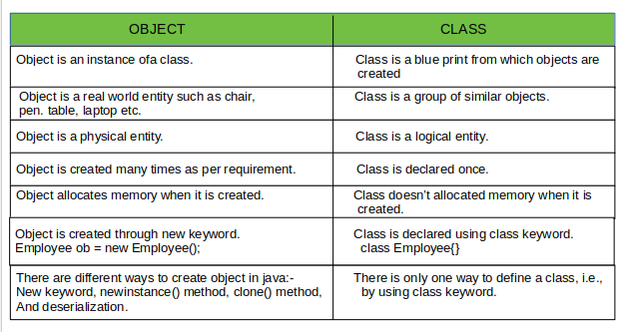

Example: Java Class and Objects
class Lamp
{
boolean isOn;
void turnOn() {
isOn = true;
System.out.println("Light on? " + isOn);
}
void turnOff() {
isOn = false;
System.out.println("Light on? " + isOn);
}
}
class Main {
public static void main(String[] args) {
Lamp led = new Lamp();
Lamp halogen = new Lamp();
led.turnOn();

halogen.turnOff();
}
}
Run Code
Output:
Light on? true
Light on? false
In the above program, we have created a class named Lamp. It contains a variable: isOn and two methods: turnOn() and turnOff().
Inside the Main class, we have created two objects: led and halogen of the Lamp class. We then used the objects to call the methods of the class.
- led.turnOn() - It sets the isOn variable to true and prints the output.
- halogen.turnOff() - It sets the isOn variable to false and prints the output.
The variable isOn defined inside the class is also called an instance variable. It is because when we create an object of the class, it is called an instance of the class. And, each instance will have its own copy of the variable.
That is, led and halogen objects will have their own copy of the isOn variable.

2. What is Strings in JAVA

Java String
In Java, string is basically an object that represents sequence of char values. An array of characters works same as Java string. For example:
- char[] ch={'j','a','v','a','t','p','o','i','n','t'};
- String s=new String(ch);
is same as:
- String s="javatpoint";
Java String class provides a lot of methods to perform operations on strings such as compare(), concat(), equals(), split(), length(), replace(), compareTo(), intern(), substring() etc.
The java.lang.String class implements Serializable, Comparable and CharSequence interfaces.

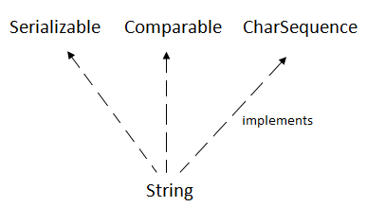

CharSequence Interface
The CharSequence interface is used to represent the sequence of characters. String, StringBuffer and StringBuilder classes implement it. It means, we can create strings in Java by using these three classes.
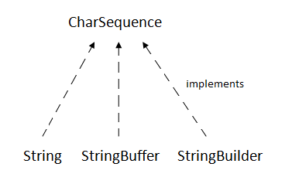
The Java String is immutable which means it cannot be changed. Whenever we change any string, a new instance is created. For mutable strings, you can use StringBuffer and StringBuilder classes.
We will discuss immutable string later. Let's first understand what String in Java is and how to create the String object.

What is String in Java?
Generally, String is a sequence of characters. But in Java, string is an object that represents a sequence of characters. The java.lang.String class is used to create a string object.

How to create a string object?
There are two ways to create String object:
- By string literal
- By new keyword

1) String Literal
Java String literal is created by using double quotes. For Example:
- String s="welcome";
Each time you create a string literal, the JVM checks the "string constant pool" first. If the string already exists in the pool, a reference to the pooled instance is returned. If the string doesn't exist in the pool, a new string instance is created and placed in the pool. For example:
- String s1="Welcome";
- String s2="Welcome";//It doesn't create a new instance
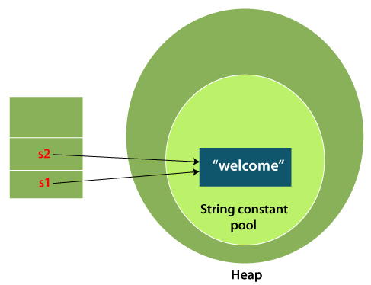
In the above example, only one object will be created. Firstly, JVM will not find any string object with the value "Welcome" in string constant pool that is why it will create a new object. After that it will find the string with the value "Welcome" in the pool, it will not create a new object but will return the reference to the same instance.

Why Java uses the concept of String literal?
To make Java more memory efficient (because no new objects are created if it exists already in the string constant pool).

2) By new keyword
- String s=new String("Welcome");//creates two objects and one reference variable
In such case, JVM will create a new string object in normal (non-pool) heap memory, and the literal "Welcome" will be placed in the string constant pool. The variable s will refer to the object in a heap (non-pool).

Java String Example
StringExample.java
- public class StringExample{
- public static void main(String args[]){
- String s1="java";//creating string by Java string literal
- char ch[]={'s','t','r','i','n','g','s'};
- String s2=new String(ch);//converting char array to string
- String s3=new String("example");//creating Java string by new keyword
- System.out.println(s1);
- System.out.println(s2);
- System.out.println(s3);
- }}
Output:
java
strings
example
The above code, converts a char array into a String object. And displays the String objects s1, s2, and s3 on console using println() method.

- What is Inheritance and its type

Inheritance in Java
Inheritance in Java is a mechanism in which one object acquires all the properties and behaviors of a parent object. It is an important part of OOPs
(Object Oriented programming system).
The idea behind inheritance in Java is that you can create new classes
that are built upon existing classes. When you inherit from an existing class, you can reuse methods and fields of the parent class. Moreover, you can add new methods and fields in your current class also.
Inheritance represents the IS-A relationship which is also known as a parent-child relationship

Why use inheritance in java
- For Method Overriding (so runtime polymorphism can be achieved).
- For Code Reusability.

Terms used in Inheritance
- Class: A class is a group of objects which have common properties. It is a template or blueprint from which objects are created.
- Sub Class/Child Class: Subclass is a class which inherits the other class. It is also called a derived class, extended class, or child class.
- Super Class/Parent Class: Superclass is the class from where a subclass inherits the features. It is also called a base class or a parent class.
- Reusability: As the name specifies, reusability is a mechanism which facilitates you to reuse the fields and methods of the existing class when you create a new class. You can use the same fields and methods already defined in the previous class.

The syntax of Java Inheritance
- class Subclass-name extends Superclass-name
- {
- //methods and fields
- }
The extends keyword indicates that you are making a new class that derives from an existing class. The meaning of "extends" is to increase the functionality.
In the terminology of Java, a class which is inherited is called a parent or superclass, and the new class is called child or subclass.
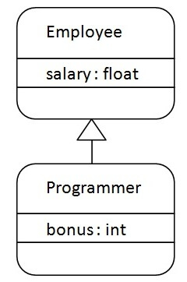
As displayed in the above figure, Programmer is the subclass and Employee is the superclass. The relationship between the two classes is Programmer IS-A Employee. It means that Programmer is a type of Employee.

- class Employee{
- float salary=40000;
- }
- class Programmer extends Employee{
- int bonus=10000;
- public static void main(String args[]){
- Programmer p=new Programmer();
- System.out.println("Programmer salary is:"+p.salary);
- System.out.println("Bonus of Programmer is:"+p.bonus);
- }
- }
Programmer salary is:40000.0
Bonus of programmer is:10000
In the above example, Programmer object can access the field of own class as well as of Employee class i.e. code reusability.

Types of inheritance in java
On the basis of class, there can be three types of inheritance in java: single, multilevel and hierarchical.
In java programming, multiple and hybrid inheritance is supported through interface only. We will learn about interfaces later.

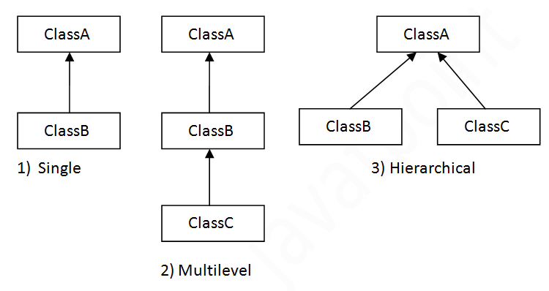Note: Multiple inheritance is not supported in Java through class.

When one class inherits multiple classes, it is known as multiple inheritance. For Example:
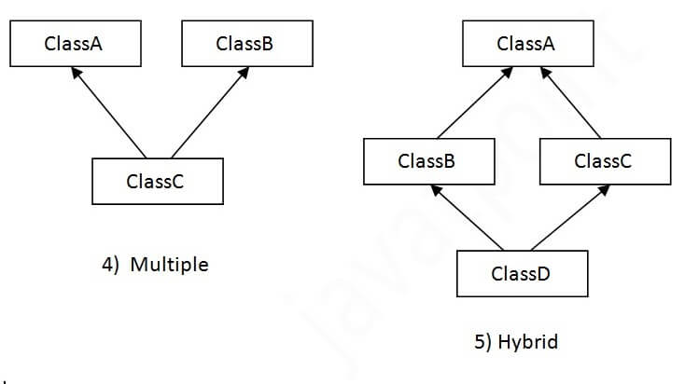
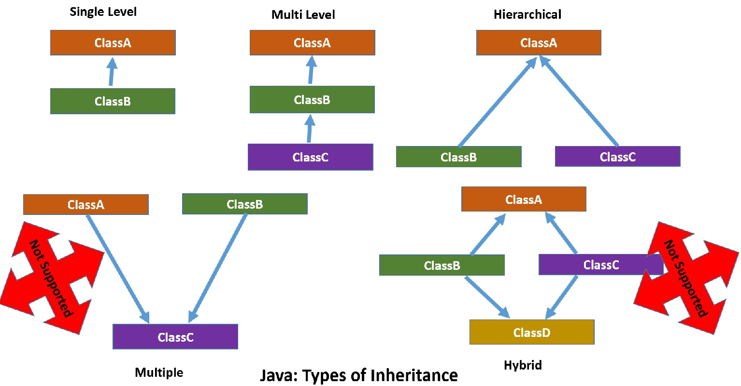
4. Where to use Interfaces in JAVA?
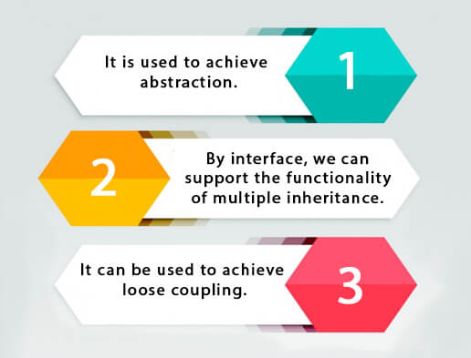

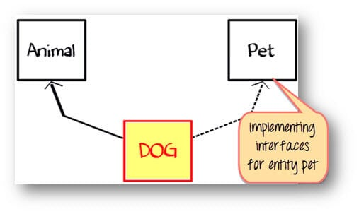

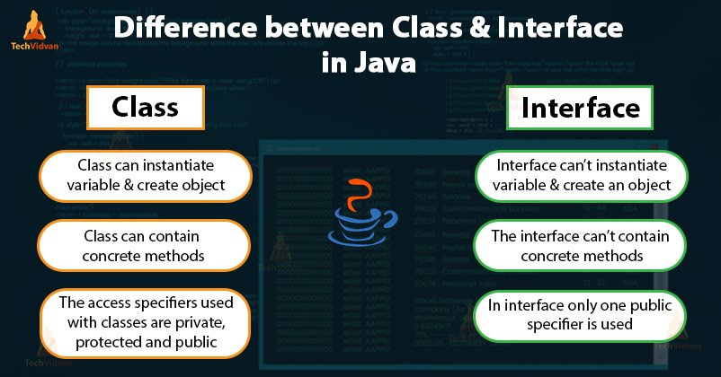

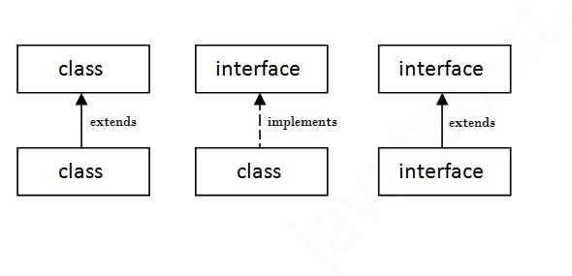

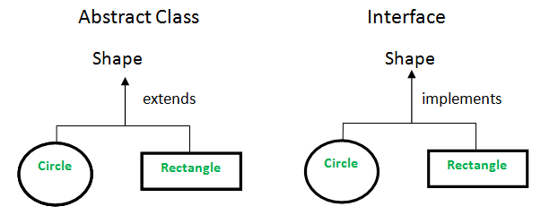

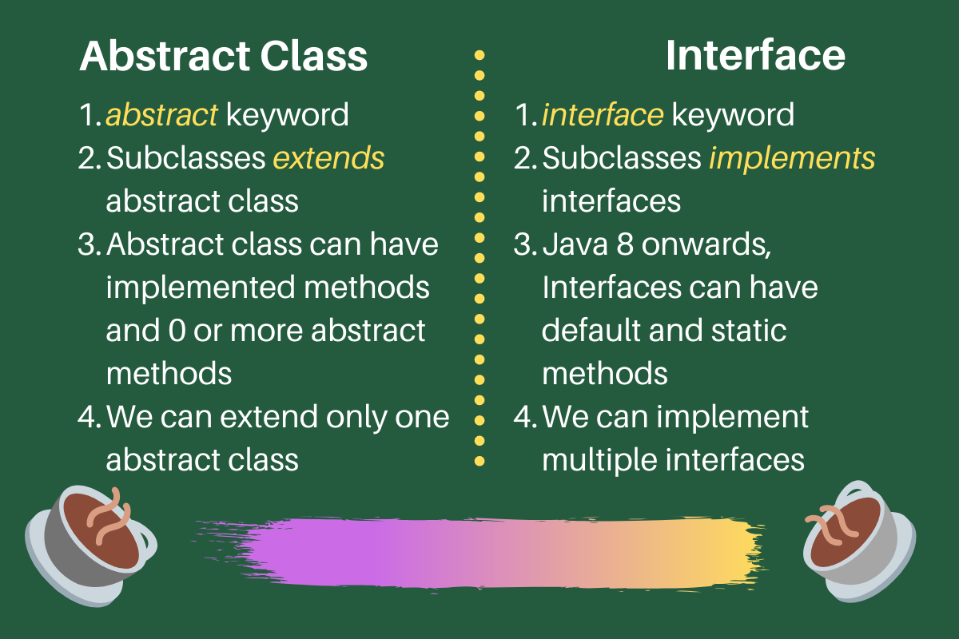

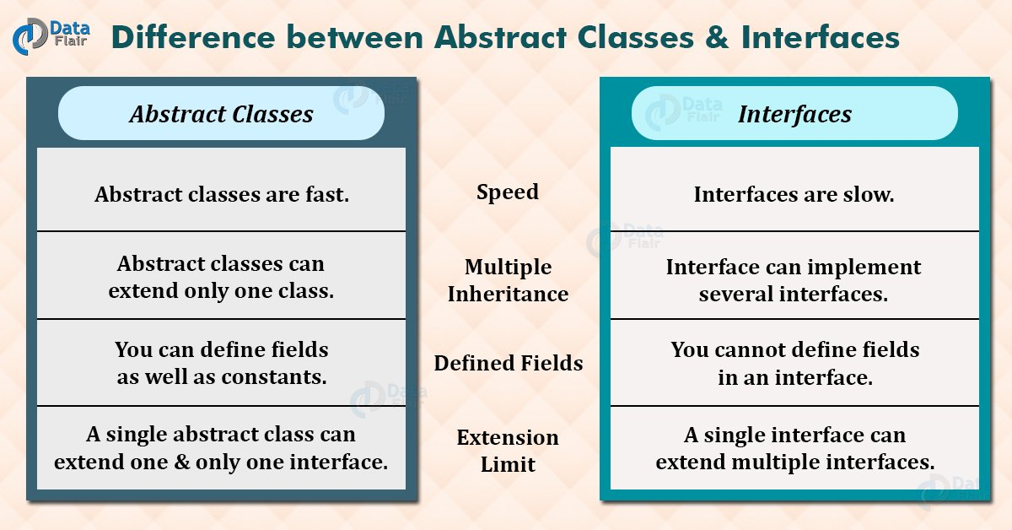

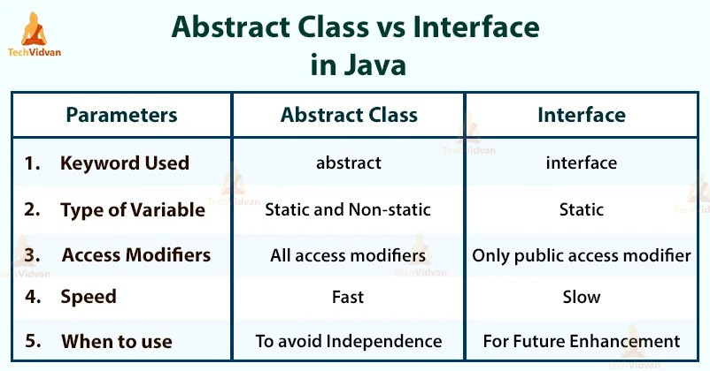

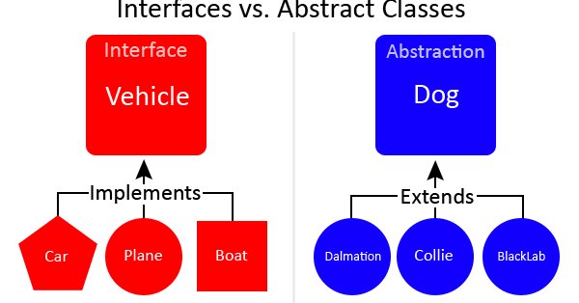

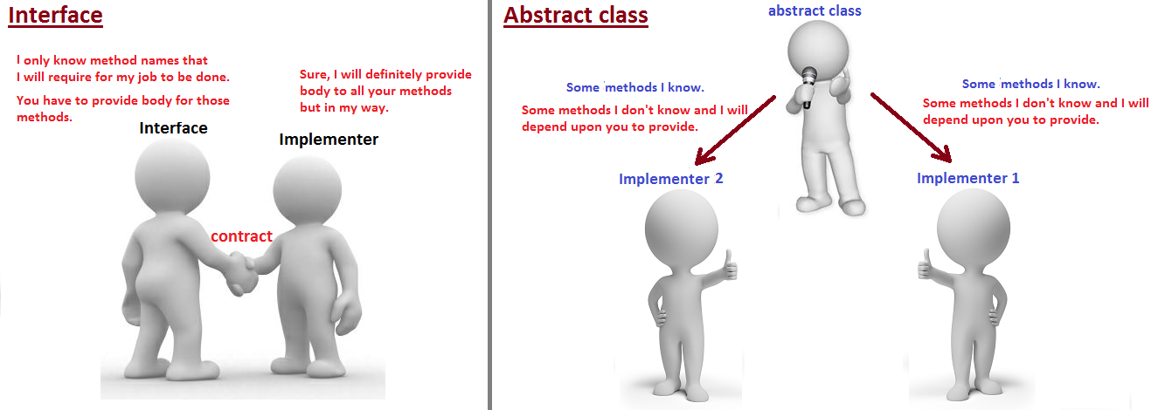

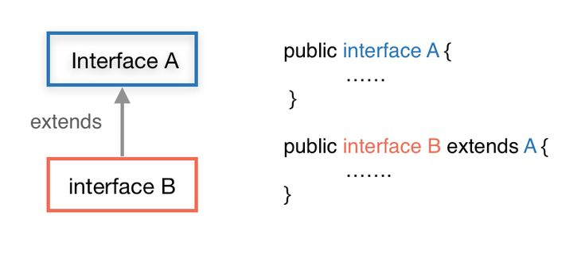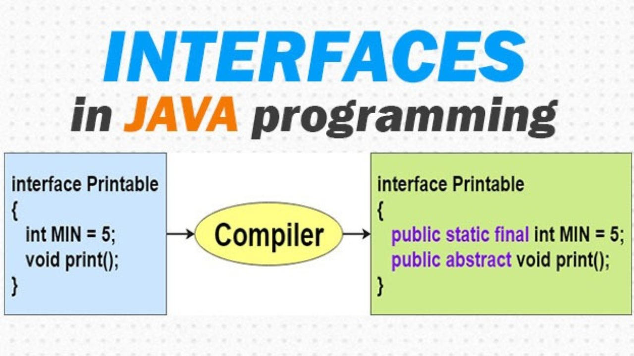

Example 1: Java Interface
interface Polygon {
void getArea(int length, int breadth);
}

// implement the Polygon interface
class Rectangle implements Polygon {

// implementation of abstract method
public void getArea(int length, int breadth) {
System.out.println("The area of the rectangle is " + (length * breadth));
}
}

class Main {
public static void main(String[] args) {
Rectangle r1 = new Rectangle();
r1.getArea(5, 6);
}
}
Run Code
Output
The area of the rectangle is 30

- List the Regular Expressions
Regular Expressions or Regex (in short) in Java is an API for defining String patterns that can be used for searching, manipulating, and editing a string in Java. Email validation and passwords are a few areas of strings where Regex is widely used to define the constraints. Regular Expressions are provided under java.util.regex package. This consists of 3 classes and 1 interface. The java.util.regex package primarily consists of the following three classes as depicted below in tabular format as follows:
S. No. | Class/Interface | Description
1. | Pattern Class | Used for defining patterns
2. | Matcher Class | Used for performing match operations on text using patterns
3. | PatternSyntaxException Class | Used for indicating syntax error in a regular expression pattern
4. | MatchResult Interface | Used for representing the result of a match operation
Regex in java provides us with 3 classes and 1 interface listed below as follows:
- Pattern Class
- Matcher Class
- PatternSyntaxException Class
- MatchResult Interface

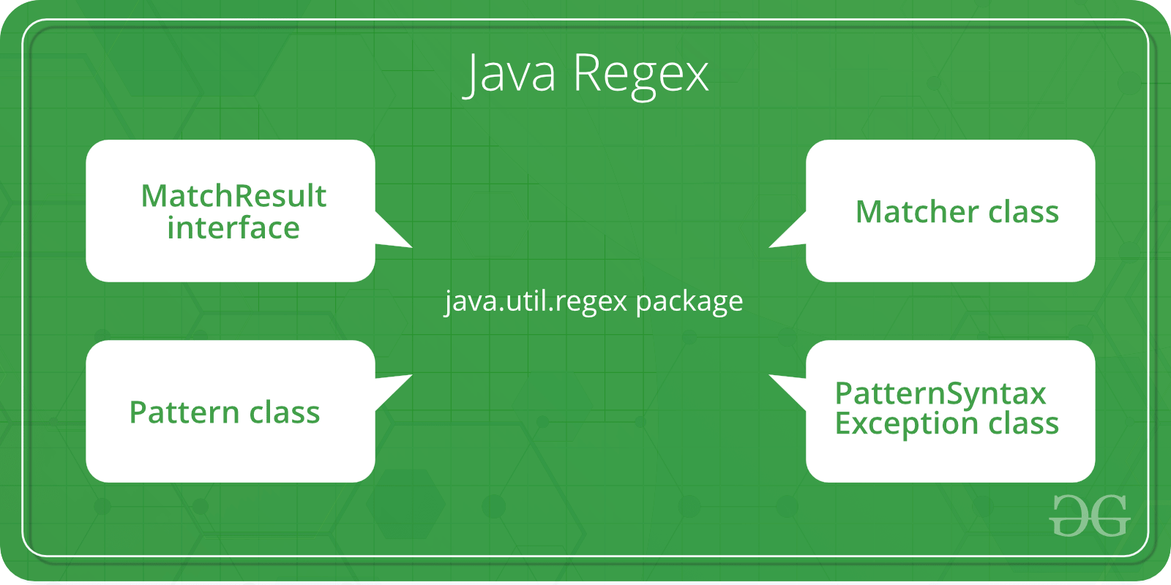

- Relate on Polymorphism
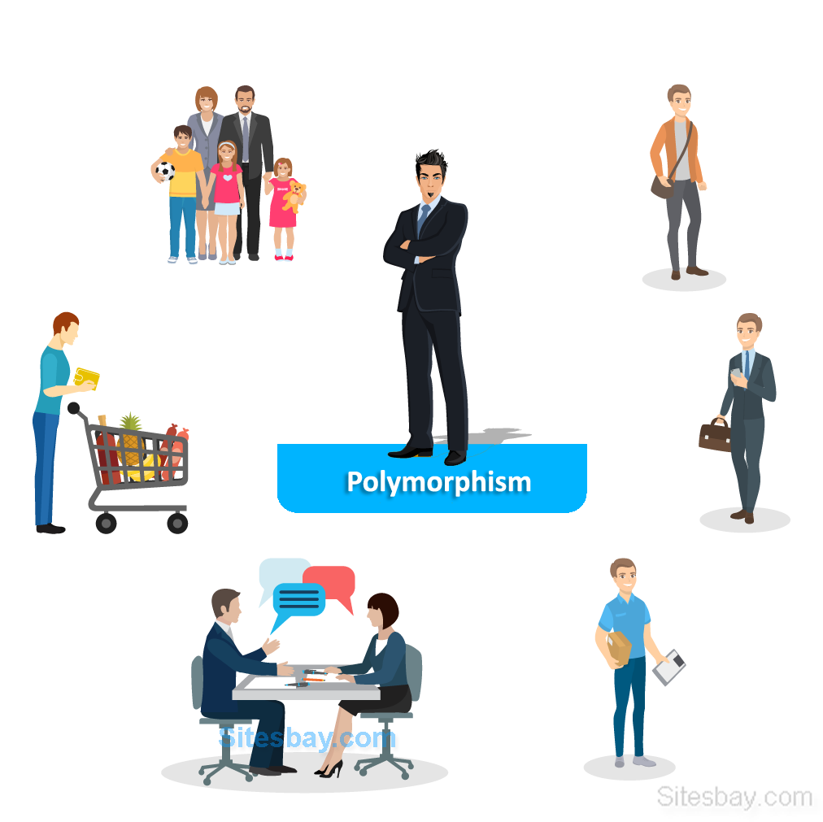

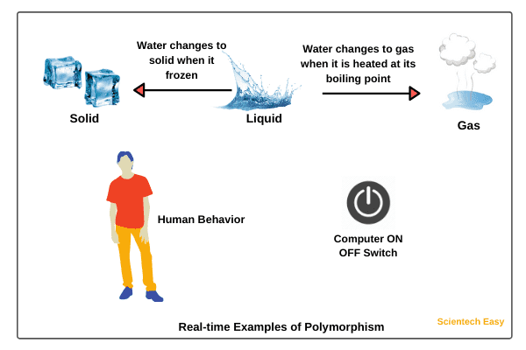

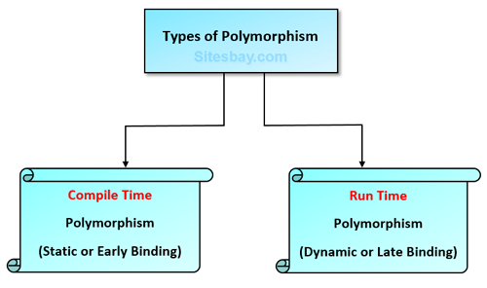
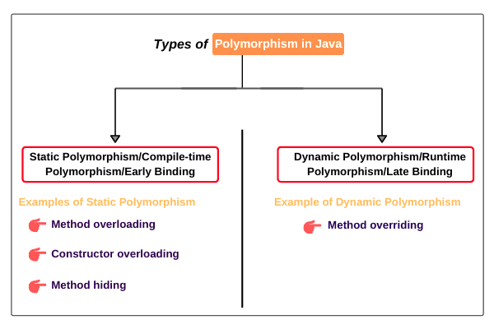

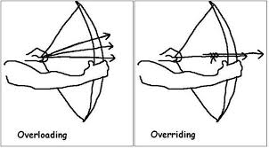
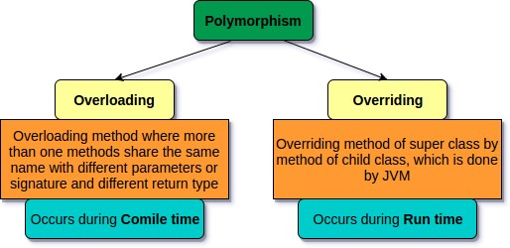

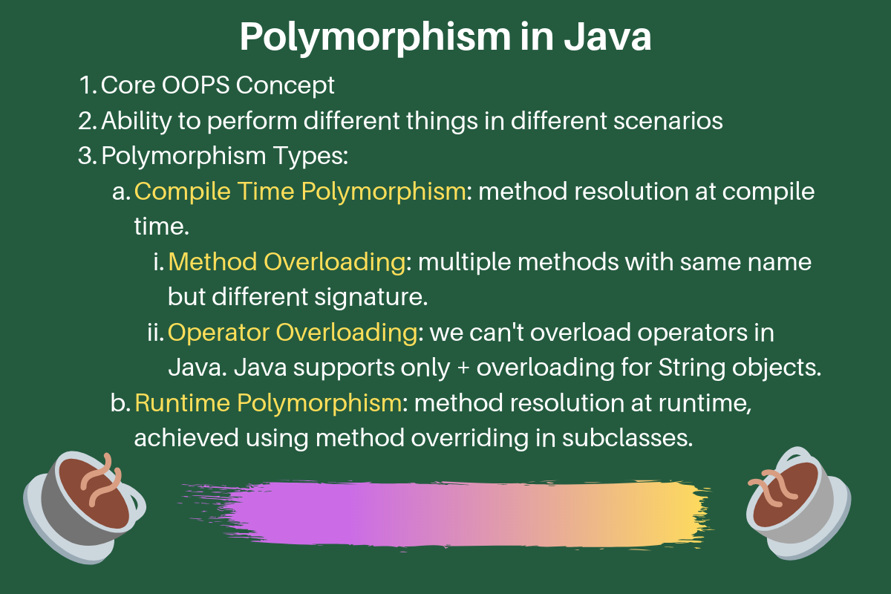
- What is Polymorphism and Interfaces in JAVA

Java language is one of the most popular languages among all programming languages. There are several advantages of using the java programming language, whether for security purposes or building large distribution projects. One of the advantages of using JA is that Java tries to connect every concept in the language to the real world with the help of the concepts of classes, inheritance, polymorphism, interfaces, etc. In this article, we will discuss polymorphism and interface concepts.
Polymorphism is that it has many forms that mean one specific defined form is used in many different ways. The simplest real-life example is let’s suppose we have to store the name of the person and the phone number of the person, but there are many situations when a person has two different phone numbers. We have to save the same phone number under the same name.
Let us interpret it with help . So, in java, the problem can be solved using an object-oriented concept, void insertPhone(String name, int phone). So, this method is used to save the phone number of the particular person. Similarly, we can use the same form but a different signature means different parameters to store the alternative phone number of the person’s void insertPhone(String name, int phone1, int phone2). One method has two different forms and performs different operations. This is an example of polymorphism, which is method overloading.
Types of polymorphism in Java:
- Run time polymorphism
- Compile-time polymorphism
Type 1: Run time polymorphism
This type of polymorphism is resolved by the java virtual machine, not by the java compiler. That’s why this type of polymorphism is called run-time polymorphism. Run time polymorphism occurs during method overriding in java.
Example
import java.io.*;
class GFG1 {
void name() {
System.out.println("This is the GFG1 class");
}
}

public class GFG extends GFG1 {

void name() {
System.out.println("This is the GFG class");
}
public static void main(String[] args) {
GFG1 ob = new GFG1();
ob.name();
GFG1 ob1 = new GFG();
ob1.name();
}
}
Output
This is the GFG1 class
This is the GFG class
Output explanation:
In the above example, the same function i.e name is called two times, but in both cases, the output is different. The signatures of these methods are also the same. That’s why compilers cannot be able to identify which should be executed. This is determined only after the object creation and reference of the class, which is performed during run time (Memory management ). That’s why this is run-time polymorphism.
Type 2: Compile-time polymorphism
Method overloading is an example of the compile-time polymorphism method. Overloading means a function having the same name but a different signature. This is compile-time polymorphism because this type of polymorphism is determined during the compilation time because during writing the code we already mention the different types of parameters for the same function name.
Example:
import java.io.*;
import java.util.*;
class First {
void check()
{
System.out.println("This is the class First");
}
}
class Second extends First {
void check(String name)
{
System.out.println("This is the class " + name);
}
public static void main(String args[])
{
Second ob = new Second();
ob.check("Second");
First ob1 = new First();
ob.check();
First ob2 = new Second();
ob.check();
}
}
Output
This is the class Second
This is the class First
This is the class First
Interfaces are very similar to classes. They have variables and methods but the interfaces allow only abstract methods(that don’t contain the body of the methods), but what is the difference between the classes and the interfaces? The first advantage is to allow interfaces to implement the multiple inheritances in a particular class. The JAVA language doesn’t support multiple inheritances if we extend multiple classes in the class, but with the help of the interfaces, multiple inheritances are allowed in Java.
Real-life Example
The real-world example of interfaces is that we have multiple classes for different levels of employees working in a particular company and the necessary property of the class is the salary of the employees and this. We must be implemented in every class and. Also, it is different for every employee here. The concept of the interface is used. We simply create an interface containing an abstract salary method and implement it in all the classes and we can easily define different salaries of the employees.
Example:
interface salary {
void insertsalary(int salary);
}
class SDE1 implements salary {
int salary;
@Override public void insertsalary(int salary)
{
this.salary = salary;
}
void printSalary() { System.out.println(this.salary); }
}
class SDE2 implements salary {
int salary;
@Override public void insertsalary(int salary)
{
this.salary = salary;
}
void printSalary() { System.out.println(this.salary); }
}
public class GFG {
public static void main(String[] args)
{
SDE1 ob = new SDE1();
ob.insertsalary(100000);
ob.printSalary();
SDE2 ob1 = new SDE2();
ob1.insertsalary(200000);
ob1.printSalary();
}
}
Output
100000
200000

- Differentiate Classes and Objects in C++ and JAVA 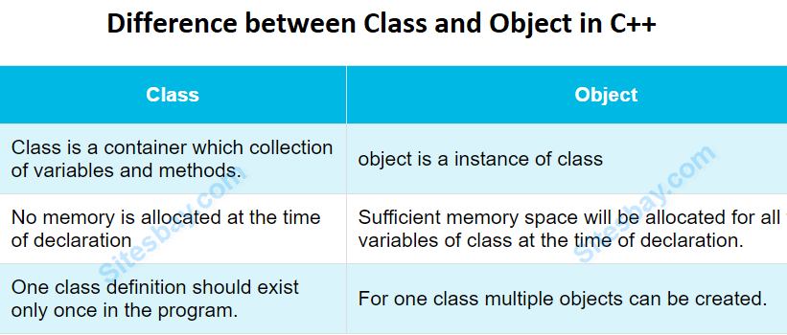

- Define the Inheritance and its types
Inheritance can be implemented in 5 ways and below are types that comes from OOPS concepts.
1) Single Inheritance
2) Multi-Level Inheritance
3) Multiple Inheritance
4) Hierarchical Inheritance
5) Hybrid Inheritance

Single Inheritance:
This is very easy to understand. If a class extends only one class then it is called as Single Inheritance. Look at the below diagram where class B extends class A.
Here always only one base class and one child class.
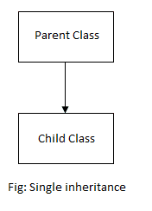
public class SingleInheritance {
public static void main(String[] args) {

A a = new A();
a.printA();

B b = new B();
b.printA();
b.printB();
}
}

class A {
public void printA() {
System.out.println("PrintA method.");
}
}

class B extends A {
public void printB() {
System.out.println("PrintB method.");
}
}
Output:
PrintA method.
PrintA method.
PrintB method.
Through object A, we can call only class A methods. But, both methods can be invoked using B object. Because class B is inheriting class A properties and methods.

Multi-Level Inheritance:
If a class is derived from another child or derived class is said to be "Multi-Level Inheritance". Derived class means a child class.
This can be minimum of three or more classes involve in this type of inheritance. For example, class B inherits class A and class C inherits class B.
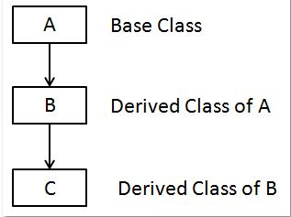

package blog.java.w3schools.inheritance;

public class MultiLevelInheritance {
public static void main(String[] args) {

C c = new C();
c.printA();
c.printB();
c.printC();
}
}

class A {
public void printA() {
System.out.println("PrintA method.");
}
}

class B extends A {
public void printB() {
System.out.println("PrintB method.");
}
}

class C extends B {
public void printC() {
System.out.println("PrintC method.");
}
}
Output:
PrintA method.
PrintB method.
PrintC method.
Observe carefully, all three methods can be invoked by object c. This is the power of inheritance.

4.3 Multiple Inheritance:
Multiple Inheritance is when one class inherits multiple classes at a time. Basically, Java does not support Multiple Inheritance.
This is not much implemented any real time projects and not supported in many OO programming languages such as Small Talk, Java, C# do not support Multiple inheritance. Only one language supports Multiple Inheritance is C++.
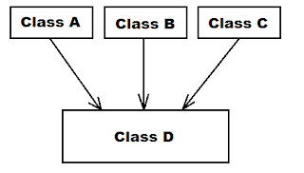
The main problem is that if both parent classes have a same method then child class which method of parent class will be accessed. This makes ambiguity to the compiler and leads to diamond problem. To avoid all these circumstances, java not supporting it.

4.4 Hierarchical Inheritance:
In simple terms, one base class - multiple child classes. A base class is inherited by many classes(child). Take a look at the below diagram.
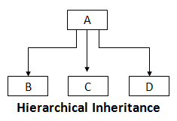
Class A is a base class.
Class B inherits class A
Class C inherits class A
Class D inherits class A
class B, C, D are inherited class A.
package blog.java.w3schools.inheritance;

public class HierarchicalInheritance {
public static void main(String[] args) {

B b = new B();
b.printA();
b.printB();

System.out.println("--------------");

C c = new C();
c.printA();
c.printC();

System.out.println("--------------");

D d = new D();
c.printA();
c.printC();
}
}

class A {
public void printA() {
System.out.println("PrintA method.");
}
}

class B extends A {
public void printB() {
System.out.println("PrintB method.");
}
}

class C extends A {
public void printC() {
System.out.println("PrintC method.");
}
}

class D extends A {
public void printD() {
System.out.println("PrintD method.");
}
}
Output:

PrintA method.
PrintB method.
--------------
PrintA method.
PrintC method.
--------------
PrintA method.
PrintC method.

Class B, C, D objects are able to call class A method directly without creating object for class A.

4.5 Hybrid Inheritance:
Hybrid Inheritance is combination of any two or more inheritances together. It may be single and multi level inheritance or multi-level or Hierarchical inheritance.
In this combination, we should not use multiple inheritance which is not supported by Java.
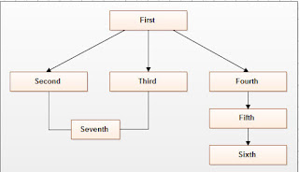

- What is Packages in JAVA
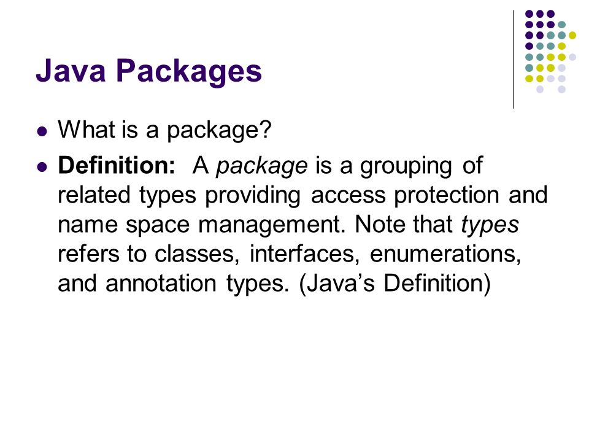

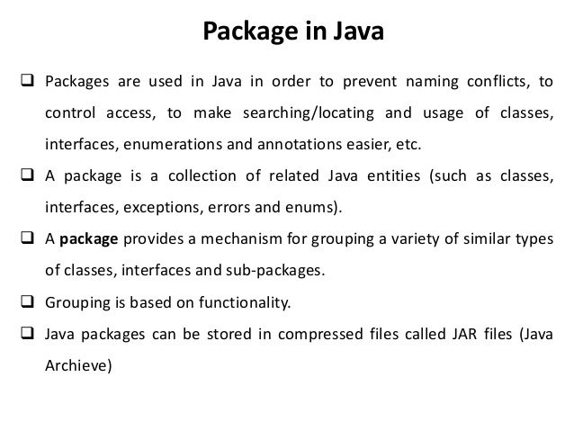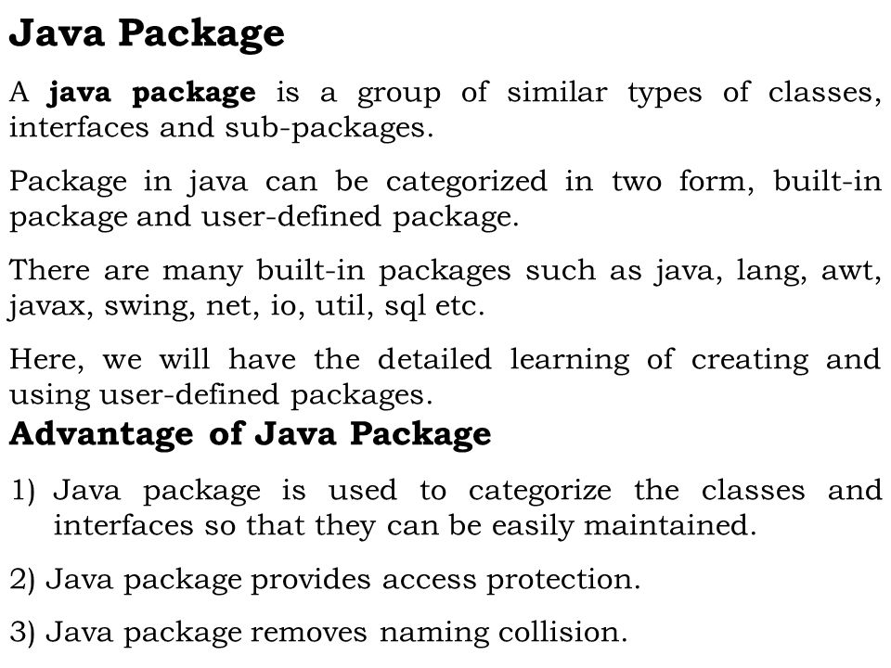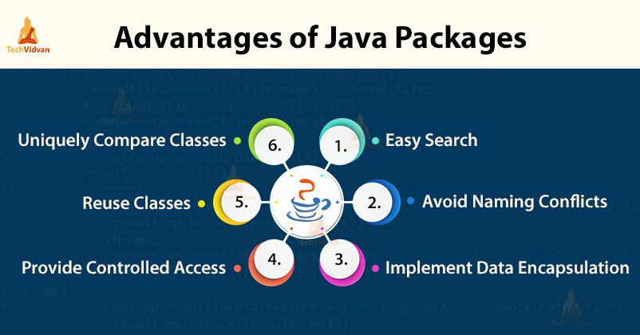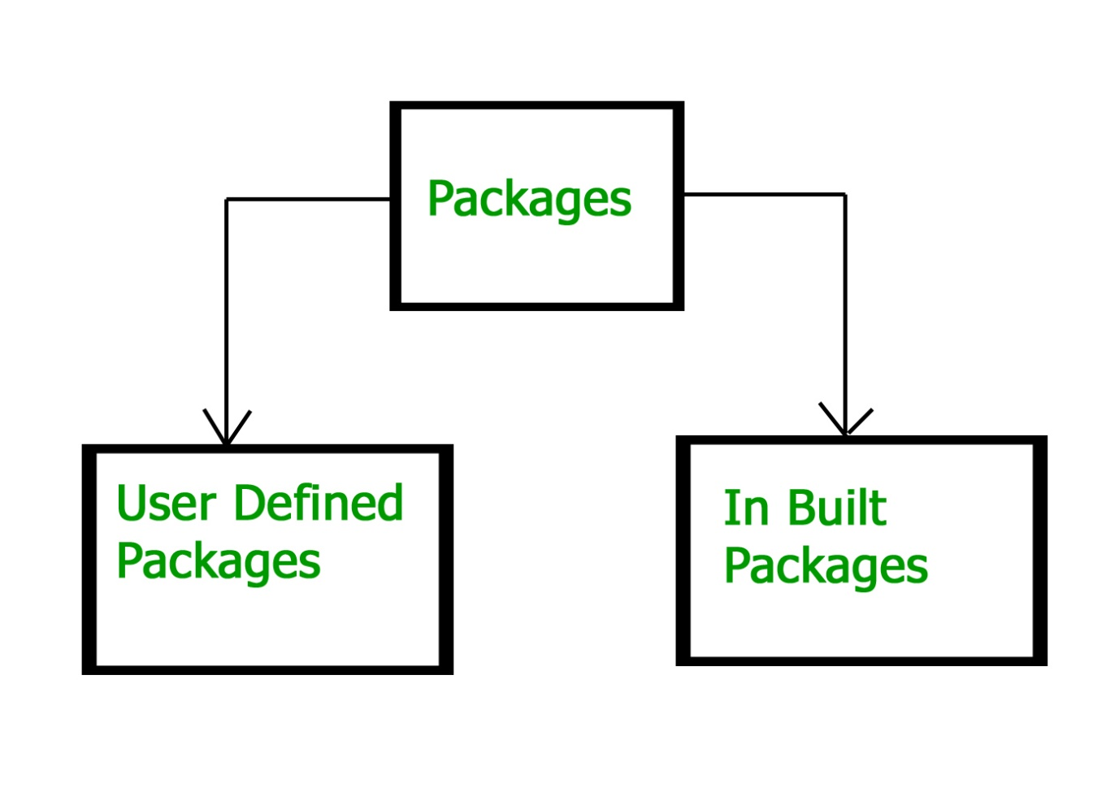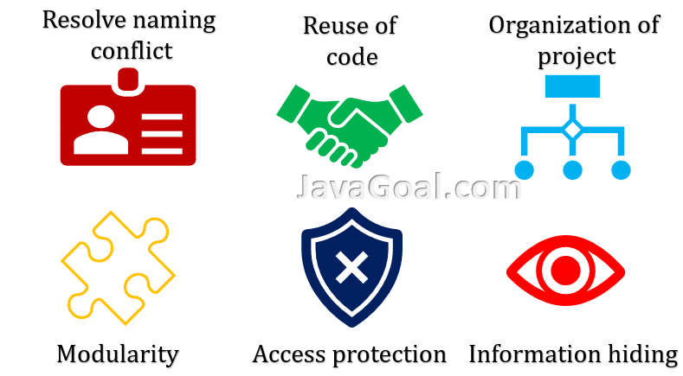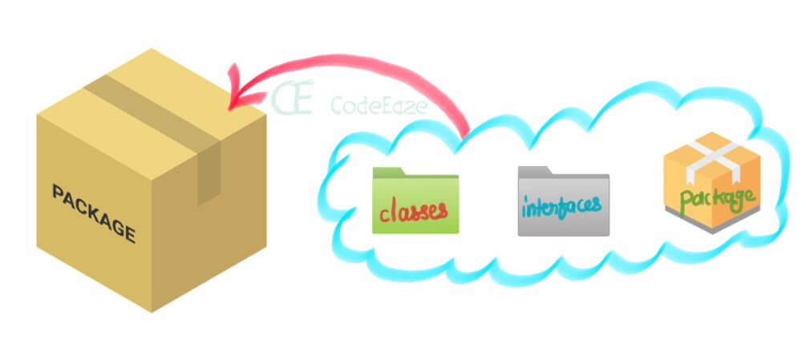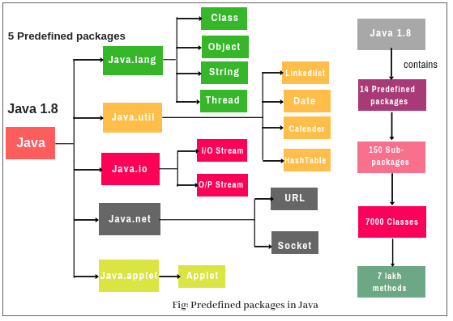
11. Discuss in detail the Exception Handling.

Java Exception Handling
In the tutorial, we will learn about different approaches of exception handling in Java with the help of examples.
In the last tutorial, we learned about Java exceptions. We know that exceptions abnormally terminate the execution of a program.
This is why it is important to handle exceptions. Here's a list of different approaches to handle exceptions in Java.
- try...catch block
- finally block
- throw and throws keyword

1. Java try...catch block
The try-catch block is used to handle exceptions in Java. Here's the syntax of try...catch block:
try {
// code
}
catch(Exception e) {
// code
}
Here, we have placed the code that might generate an exception inside the try block. Every try block is followed by a catch block.
When an exception occurs, it is caught by the catch block. The catch block cannot be used without the try block.

Example: Exception handling using try...catch
class Main {
public static void main(String[] args) {

try {

// code that generate exception
int divideByZero = 5 / 0;
System.out.println("Rest of code in try block");
}

catch (ArithmeticException e) {
System.out.println("ArithmeticException => " + e.getMessage());
}
}
}
Run Code
Output
ArithmeticException => / by zero
In the example, we are trying to divide a number by 0. Here, this code generates an exception.
To handle the exception, we have put the code, 5 / 0 inside the try block. Now when an exception occurs, the rest of the code inside the try block is skipped.
The catch block catches the exception and statements inside the catch block is executed.
If none of the statements in the try block generates an exception, the catch block is skipped.

2. Java finally block
In Java, the finally block is always executed no matter whether there is an exception or not.
The finally block is optional. And, for each try block, there can be only one finally block.
The basic syntax of finally block is:
try {
//code
}
catch (ExceptionType1 e1) {
// catch block
}
finally {
// finally block always executes
}
If an exception occurs, the finally block is executed after the try...catch block. Otherwise, it is executed after the try block. For each try block, there can be only one finally block.

Example: Java Exception Handling using finally block
class Main {
public static void main(String[] args) {
try {
// code that generates exception
int divideByZero = 5 / 0;
}

catch (ArithmeticException e) {
System.out.println("ArithmeticException => " + e.getMessage());
}

finally {
System.out.println("This is the finally block");
}
}
}
Run Code
Output
ArithmeticException => / by zero
This is the finally block
In the above example, we are dividing a number by 0 inside the try block. Here, this code generates an ArithmeticException.
The exception is caught by the catch block. And, then the finally block is executed.
Note: It is a good practice to use the finally block. It is because it can include important cleanup codes like,
- code that might be accidentally skipped by return, continue or break
- closing a file or connection

3. Java throw and throws keyword
The Java throw keyword is used to explicitly throw a single exception.
When we throw an exception, the flow of the program moves from the try block to the catch block.

Example: Exception handling using Java throw
class Main {
public static void divideByZero() {

// throw an exception
throw new ArithmeticException("Trying to divide by 0");
}

public static void main(String[] args) {
divideByZero();
}
}
Run Code
Output
Exception in thread "main" java.lang.ArithmeticException: Trying to divide by 0
at Main.divideByZero(Main.java:5)
at Main.main(Main.java:9)
In the above example, we are explicitly throwing the ArithmeticException using the throw keyword.
Similarly, the throws keyword is used to declare the type of exceptions that might occur within the method. It is used in the method declaration.

Example: Java throws keyword
import java.io.*;

class Main {
// declareing the type of exception
public static void findFile() throws IOException {

// code that may generate IOException
File newFile = new File("test.txt");
FileInputStream stream = new FileInputStream(newFile);
}

public static void main(String[] args) {
try {
findFile();
}
catch (IOException e) {
System.out.println(e);
}
}
}
Run Code
Output
java.io.FileNotFoundException: test.txt (The system cannot find the file specified)
When we run this program, if the file test.txt does not exist, FileInputStream throws a FileNotFoundException which extends the IOException class.
The findFile() method specifies that an IOException can be thrown. The main() method calls this method and handles the exception if it is thrown.
If a method does not handle exceptions, the type of exceptions that may occur within it must be specified in the throws clause.

- Summarize the JAVA Structure

Structure of Java Program
Java is an object-oriented programming
, platform-independent, and secure programming language that makes it popular. Using the Java programming language, we can develop a wide variety of applications. So, before diving in depth, it is necessary to understand the basic structure of Java program in detail. In this section, we have discussed the basic structure of a Java program. At the end of this section, you will able to develop the Hello world Java program
, easily.
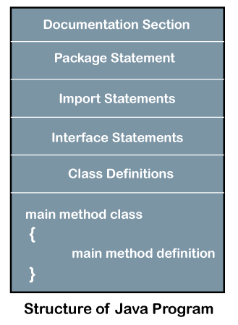
Let's see which elements are included in the structure of a Java program
. A typical structure of a Java
program contains the following elements:
- Documentation Section
- Package Declaration
- Import Statements
- Interface Section
- Class Definition
- Class Variables and Variables
- Main Method Class
- Methods and Behaviors

Documentation Section
The documentation section is an important section but optional for a Java program. It includes basic information about a Java program. The information includes the author's name, date of creation, version, program name, company name, and description of the program. It improves the readability of the program. Whatever we write in the documentation section, the Java compiler ignores the statements during the execution of the program. To write the statements in the documentation section, we use comments. The comments may be single-line, multi-line, and documentation comments.
- Single-line Comment: It starts with a pair of forwarding slash (//). For example:
- //First Java Program
- Multi-line Comment: It starts with a /* and ends with */. We write between these two symbols. For example:
- /*It is an example of
- multiline comment*/
- Documentation Comment: It starts with the delimiter (/**) and ends with */. For example:
- /**It is an example of documentation comment*/

Package Declaration
The package declaration is optional. It is placed just after the documentation section. In this section, we declare the package name in which the class is placed. Note that there can be only one package statement in a Java program. It must be defined before any class and interface declaration. It is necessary because a Java class can be placed in different packages and directories based on the module they are used. For all these classes package belongs to a single parent directory. We use the keyword package to declare the package name. For example:
Competitive questions on Structures in HindiKeep Watching

- package javatpoint; //where javatpoint is the package name
- package com.javatpoint; //where com is the root directory and javatpoint is the subdirectory

Import Statements
The package contains the many predefined classes and interfaces. If we want to use any class of a particular package, we need to import that class. The import statement represents the class stored in the other package. We use the import keyword to import the class. It is written before the class declaration and after the package statement. We use the import statement in two ways, either import a specific class or import all classes of a particular package. In a Java program, we can use multiple import statements. For example:
- import java.util.Scanner; //it imports the Scanner class only
- import java.util.*; //it imports all the class of the java.util package

Interface Section
It is an optional section. We can create an interface in this section if required. We use the interface keyword to create an interface. An interface
is a slightly different from the class. It contains only constants and method declarations. Another difference is that it cannot be instantiated. We can use interface in classes by using the implements keyword. An interface can also be used with other interfaces by using the extends keyword. For example:
- interface car
- {
- void start();
- void stop();
- }

Class Definition
In this section, we define the class. It is vital part of a Java program. Without the class
, we cannot create any Java program. A Java program may conation more than one class definition. We use the class keyword to define the class. The class is a blueprint of a Java program. It contains information about user-defined methods, variables, and constants. Every Java program has at least one class that contains the main() method. For example:
- class Student //class definition
- {
- }

Class Variables and Constants
In this section, we define variables
and constants that are to be used later in the program. In a Java program, the variables and constants are defined just after the class definition. The variables and constants store values of the parameters. It is used during the execution of the program. We can also decide and define the scope of variables by using the modifiers. It defines the life of the variables. For example:
- class Student //class definition
- {
- String sname; //variable
- int id;
- double percentage;
- }

Main Method Class
In this section, we define the main() method. It is essential for all Java programs. Because the execution of all Java programs starts from the main() method. In other words, it is an entry point of the class. It must be inside the class. Inside the main method, we create objects and call the methods. We use the following statement to define the main() method:
- public static void main(String args[])
- {
- }
For example:
- public class Student //class definition
- {
- public static void main(String args[])
- {
- //statements
- }
- }
You can read more about the Java main() method here
Methods and behavior
In this section, we define the functionality of the program by using the methods
. The methods are the set of instructions that we want to perform. These instructions execute at runtime and perform the specified task. For example:
- public class Demo //class definition
- {
- public static void main(String args[])
- {
- void display()
- {
- System.out.println("Welcome to java");
- }
- //statements
- }
- }

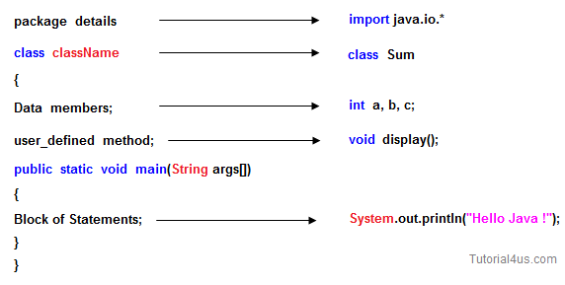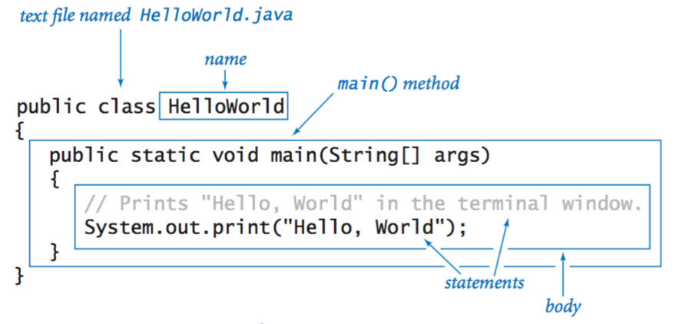

13. How to add Interfaces to your JAVA Program?
In the last tutorial we discussed abstract class which is used for achieving partial abstraction. Unlike abstract class an interface is used for full abstraction. Abstraction is a process where you show only “relevant” data and “hide” unnecessary details of an object from the user(See: Abstraction). In this guide, we will cover what is an interface in java, why we use it and what are rules that we must follow while using interfaces in Java Programming.

What is an interface in Java?
Interface looks like a class but it is not a class. An interface can have methods and variables just like the class but the methods declared in interface are by default abstract (only method signature, no body, see: Java abstract method). Also, the variables declared in an interface are public, static & final by default. We will cover this in detail, later in this guide.

What is the use of interface in Java?
As mentioned above they are used for full abstraction. Since methods in interfaces do not have body, they have to be implemented by the class before you can access them. The class that implements interface must implement all the methods of that interface. Also, java programming language does not allow you to extend more than one class, However you can implement more than one interfaces in your class.
Syntax:
Interfaces are declared by specifying a keyword “interface”. E.g.:
interface MyInterface
{
/* All the methods are public abstract by default
* As you see they have no body
*/
public void method1();
public void method2();
}

Example of an Interface in Java
This is how a class implements an interface. It has to provide the body of all the methods that are declared in interface or in other words you can say that class has to implement all the methods of interface.
Do you know? class implements interface but an interface extends another interface.
interface MyInterface
{
/* compiler will treat them as:
* public abstract void method1();
* public abstract void method2();
*/
public void method1();
public void method2();
}
class Demo implements MyInterface
{
/* This class must have to implement both the abstract methods
* else you will get compilation error
*/
public void method1()
{
System.out.println("implementation of method1");
}
public void method2()
{
System.out.println("implementation of method2");
}
public static void main(String arg[])
{
MyInterface obj = new Demo();
obj.method1();
}
}
Output:
implementation of method1

14. Describe about designing tools in multimedia

15. Discuss about Exception Handling in JAVA

Java Exception Handling
In the tutorial, we will learn about different approaches of exception handling in Java with the help of examples.
In the last tutorial, we learned about Java exceptions. We know that exceptions abnormally terminate the execution of a program.
This is why it is important to handle exceptions. Here's a list of different approaches to handle exceptions in Java.
- try...catch block
- finally block
- throw and throws keyword

1. Java try...catch block
The try-catch block is used to handle exceptions in Java. Here's the syntax of try...catch block:
try {
// code
}
catch(Exception e) {
// code
}
Here, we have placed the code that might generate an exception inside the try block. Every try block is followed by a catch block.
When an exception occurs, it is caught by the catch block. The catch block cannot be used without the try block.

Example: Exception handling using try...catch
class Main {
public static void main(String[] args) {

try {

// code that generate exception
int divideByZero = 5 / 0;
System.out.println("Rest of code in try block");
}

catch (ArithmeticException e) {
System.out.println("ArithmeticException => " + e.getMessage());
}
}
}
Run Code
Output
ArithmeticException => / by zero
In the example, we are trying to divide a number by 0. Here, this code generates an exception.
To handle the exception, we have put the code, 5 / 0 inside the try block. Now when an exception occurs, the rest of the code inside the try block is skipped.
The catch block catches the exception and statements inside the catch block is executed.
If none of the statements in the try block generates an exception, the catch block is skipped.

2. Java finally block
In Java, the finally block is always executed no matter whether there is an exception or not.
The finally block is optional. And, for each try block, there can be only one finally block.
The basic syntax of finally block is:
try {
//code
}
catch (ExceptionType1 e1) {
// catch block
}
finally {
// finally block always executes
}
If an exception occurs, the finally block is executed after the try...catch block. Otherwise, it is executed after the try block. For each try block, there can be only one finally block.

Example: Java Exception Handling using finally block
class Main {
public static void main(String[] args) {
try {
// code that generates exception
int divideByZero = 5 / 0;
}

catch (ArithmeticException e) {
System.out.println("ArithmeticException => " + e.getMessage());
}

finally {
System.out.println("This is the finally block");
}
}
}
Run Code
Output
ArithmeticException => / by zero
This is the finally block
In the above example, we are dividing a number by 0 inside the try block. Here, this code generates an ArithmeticException.
The exception is caught by the catch block. And, then the finally block is executed.
Note: It is a good practice to use the finally block. It is because it can include important cleanup codes like,
- code that might be accidentally skipped by return, continue or break
- closing a file or connection

3. Java throw and throws keyword
The Java throw keyword is used to explicitly throw a single exception.
When we throw an exception, the flow of the program moves from the try block to the catch block.

Example: Exception handling using Java throw
class Main {
public static void divideByZero() {

// throw an exception
throw new ArithmeticException("Trying to divide by 0");
}

public static void main(String[] args) {
divideByZero();
}
}
Run Code
Output
Exception in thread "main" java.lang.ArithmeticException: Trying to divide by 0
at Main.divideByZero(Main.java:5)
at Main.main(Main.java:9)
In the above example, we are explicitly throwing the ArithmeticException using the throw keyword.
Similarly, the throws keyword is used to declare the type of exceptions that might occur within the method. It is used in the method declaration.

Example: Java throws keyword
import java.io.*;

class Main {
// declareing the type of exception
public static void findFile() throws IOException {

// code that may generate IOException
File newFile = new File("test.txt");
FileInputStream stream = new FileInputStream(newFile);
}

public static void main(String[] args) {
try {
findFile();
}
catch (IOException e) {
System.out.println(e);
}
}
}
Run Code
Output
java.io.FileNotFoundException: test.txt (The system cannot find the file specified)
When we run this program, if the file test.txt does not exist, FileInputStream throws a FileNotFoundException which extends the IOException class.
The findFile() method specifies that an IOException can be thrown. The main() method calls this method and handles the exception if it is thrown.
If a method does not handle exceptions, the type of exceptions that may occur within it must be specified in the throws clause.

